**Installation of Eclipse Software:**

Step1:Download the Software

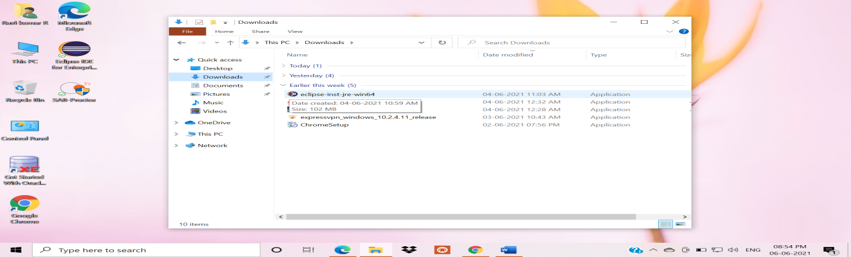

Step2:Double Click on the Software



Step3:Selcet Eclipse IDE for Enterprises Java and Web Developers



Step4:After step3 Click on Install Button



Step5:Installation Process

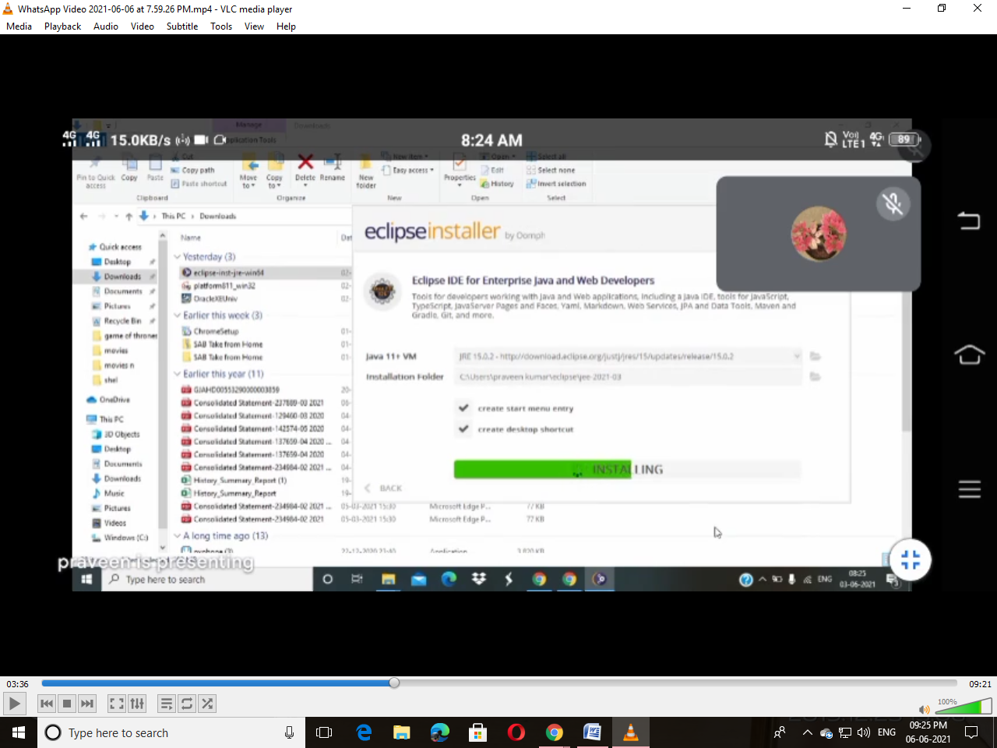

Step6:After Installation Click on Lunch Button

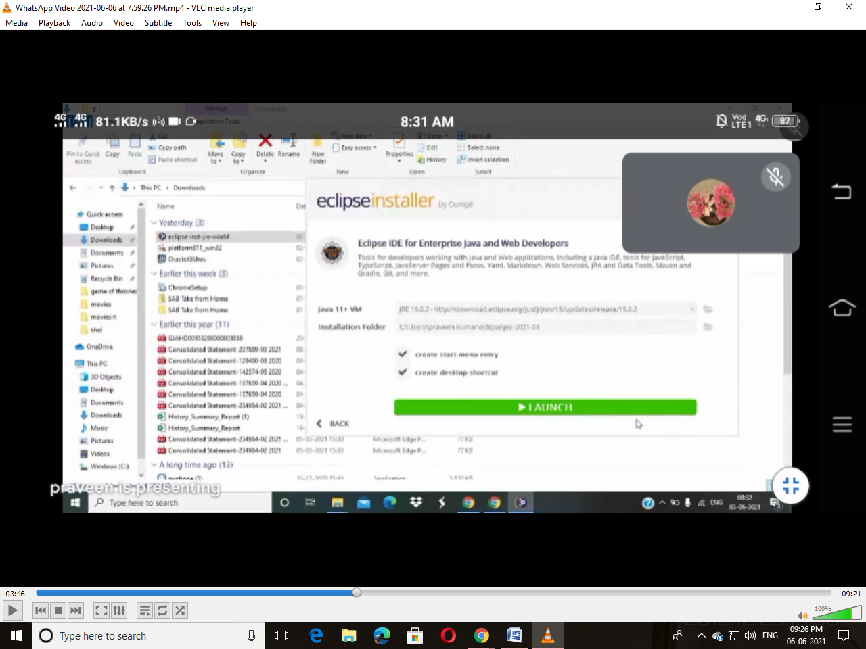

Step7:Select Directory and Click again Lunch Button

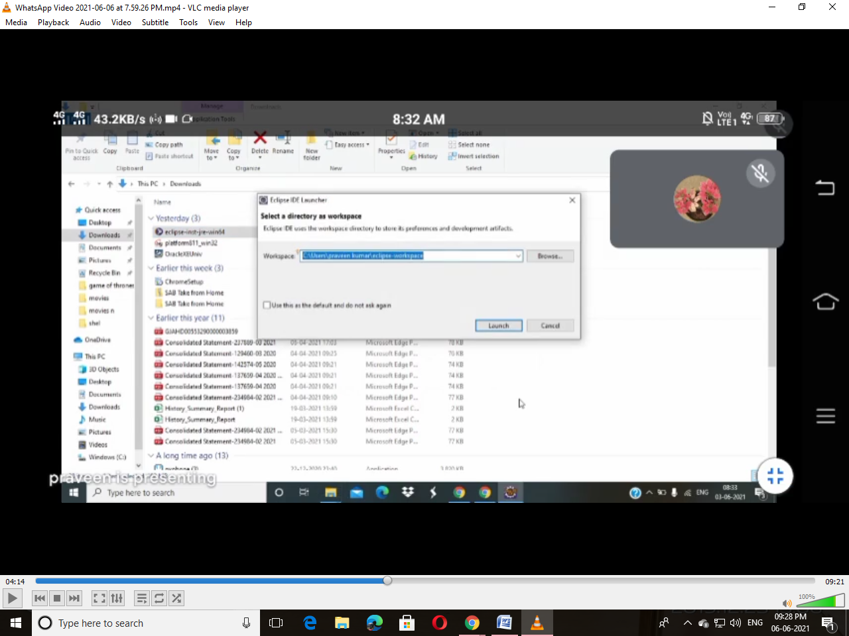

Step8:After step7 Close that Window which is show in the Picture

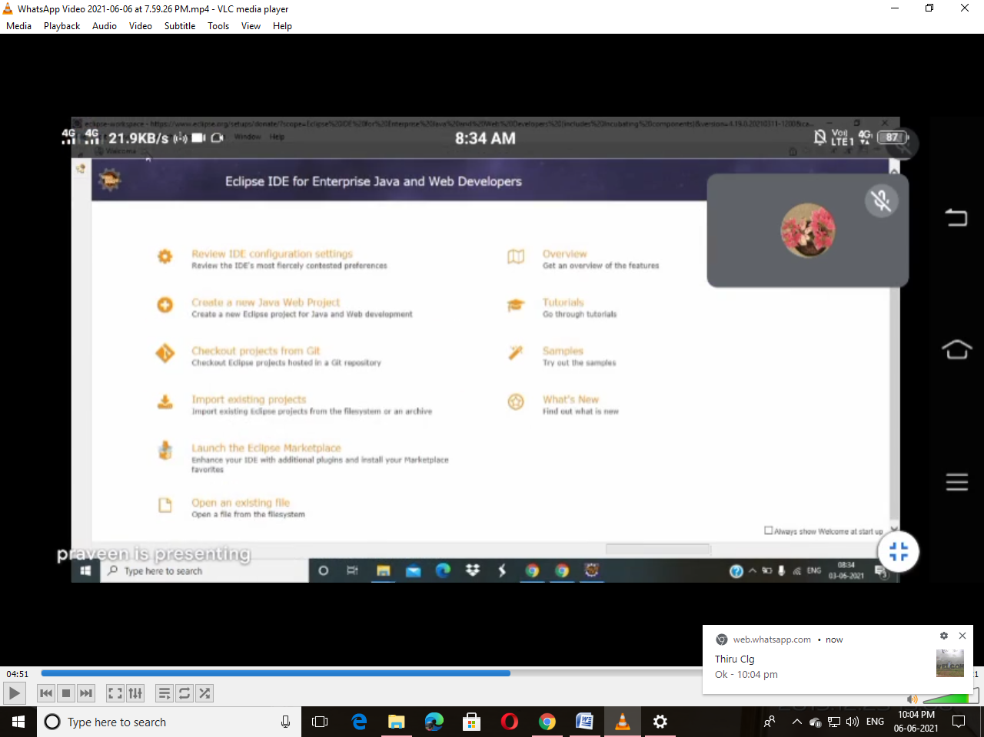

Step9:After Closing the Window it Displays like this show in below Picture

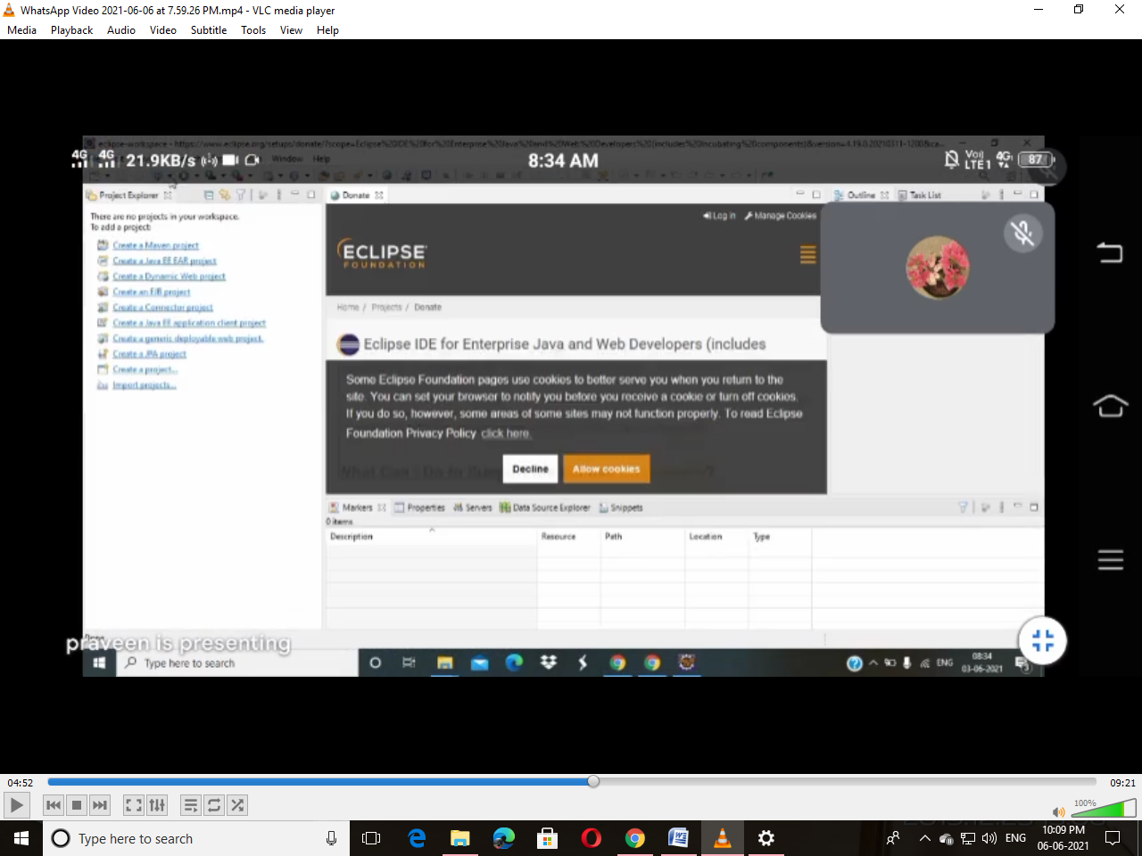

Step10:Cancal the Donate Window

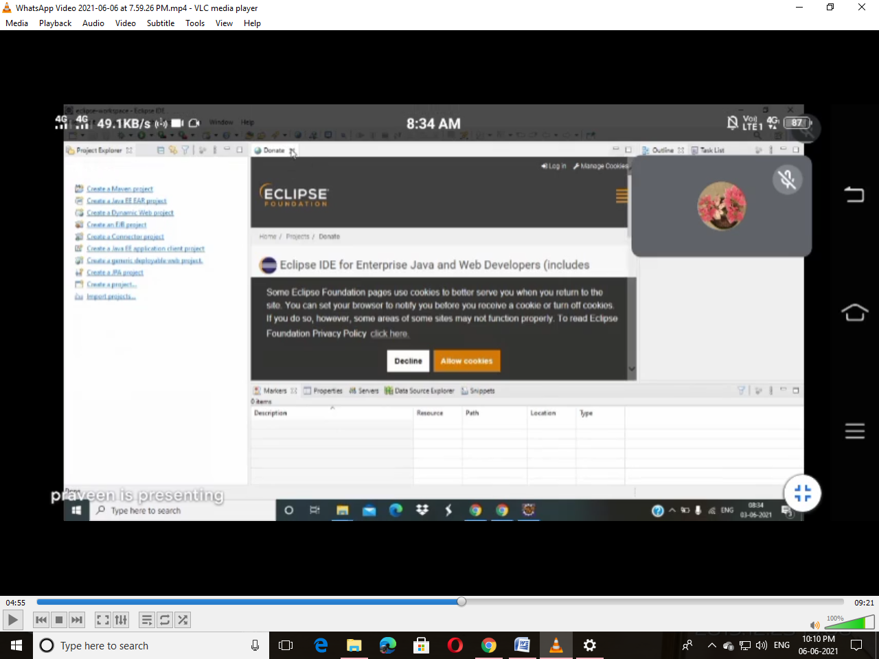

Step11:Select the Prespective which is right side of the Window

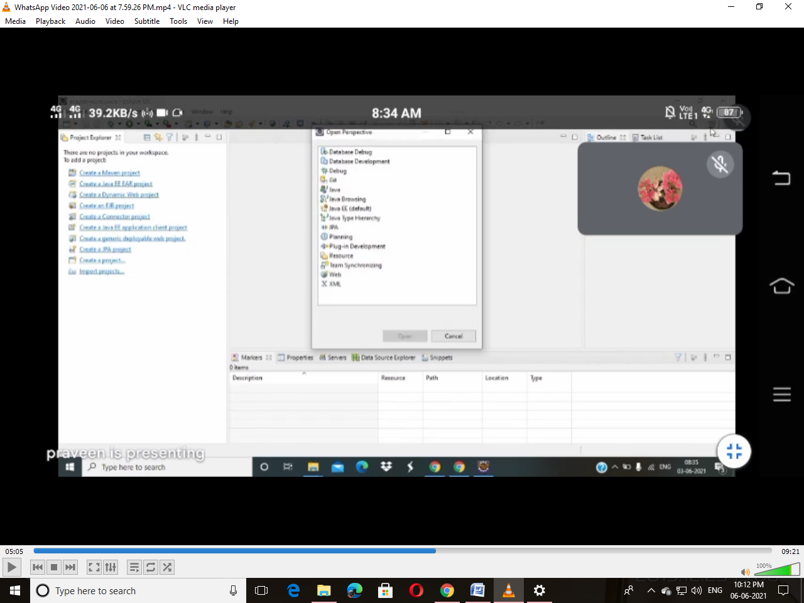

Step12:Select Java form Perspective Window

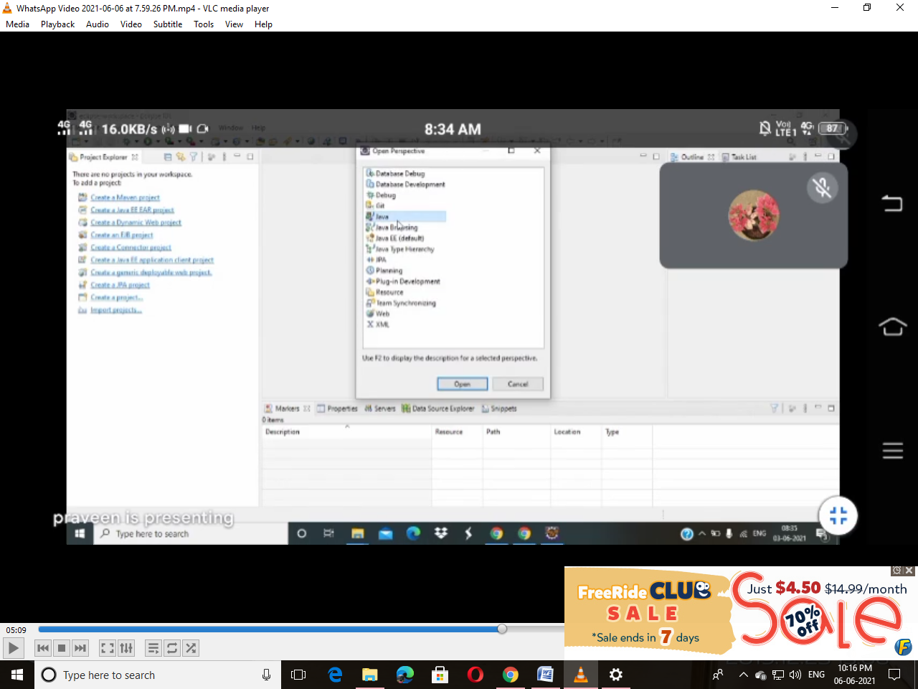

Step13:After step12 Click on File and Select New from that Select Java Project

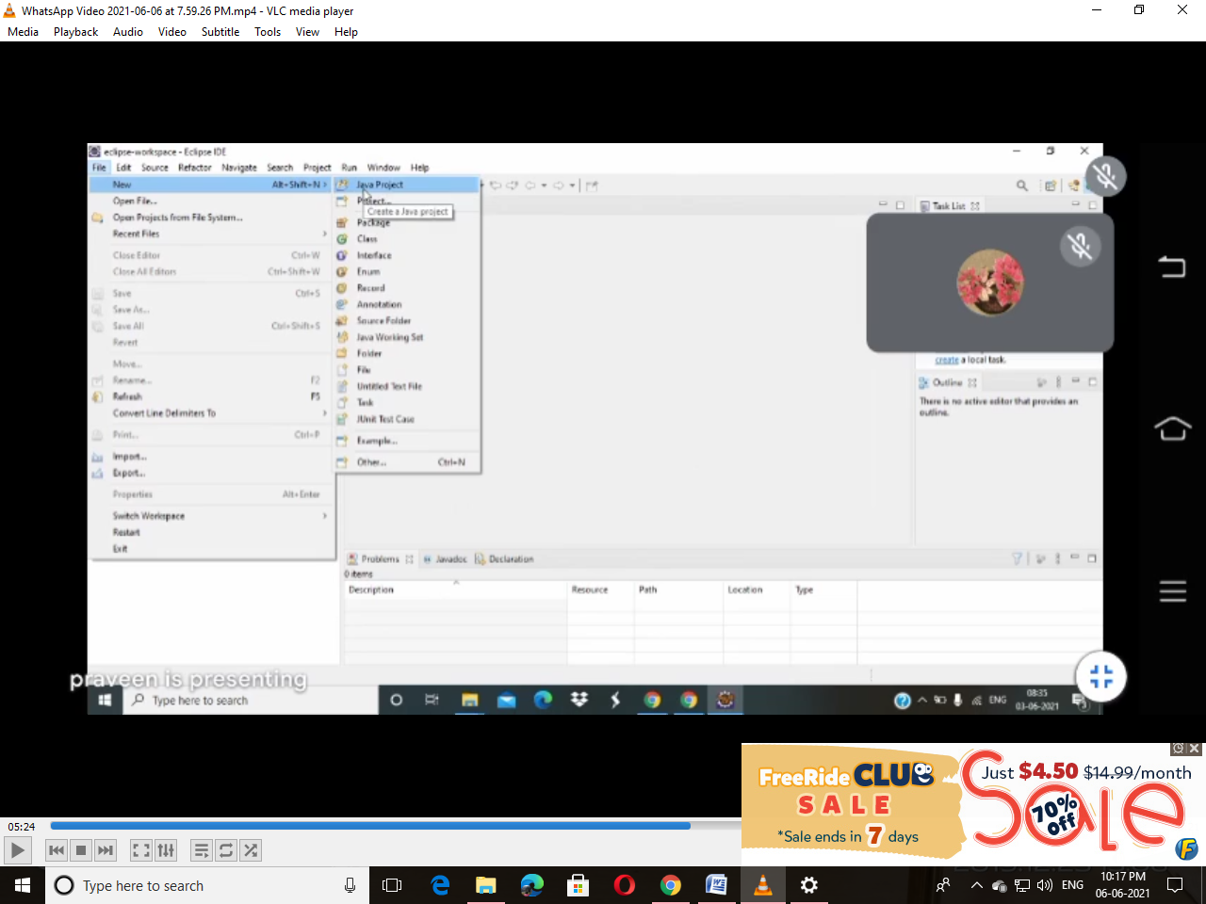

Step14:Set Name for your Project and Click Next Button

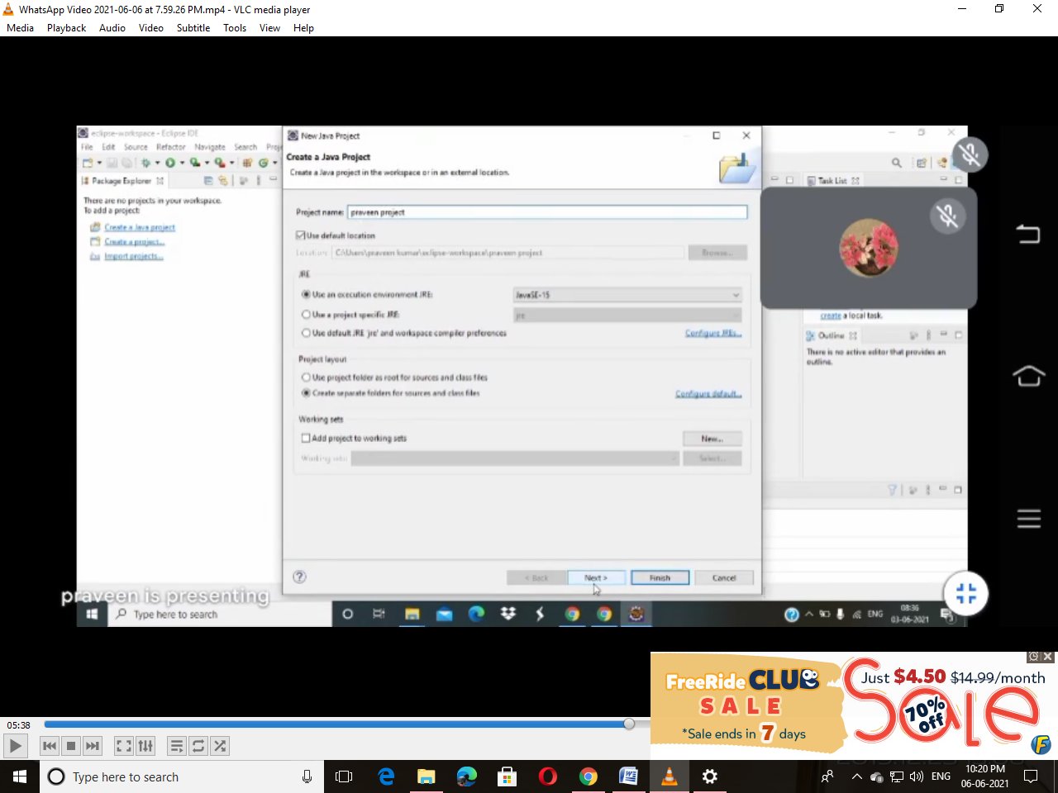

Step15:Select Finish Button

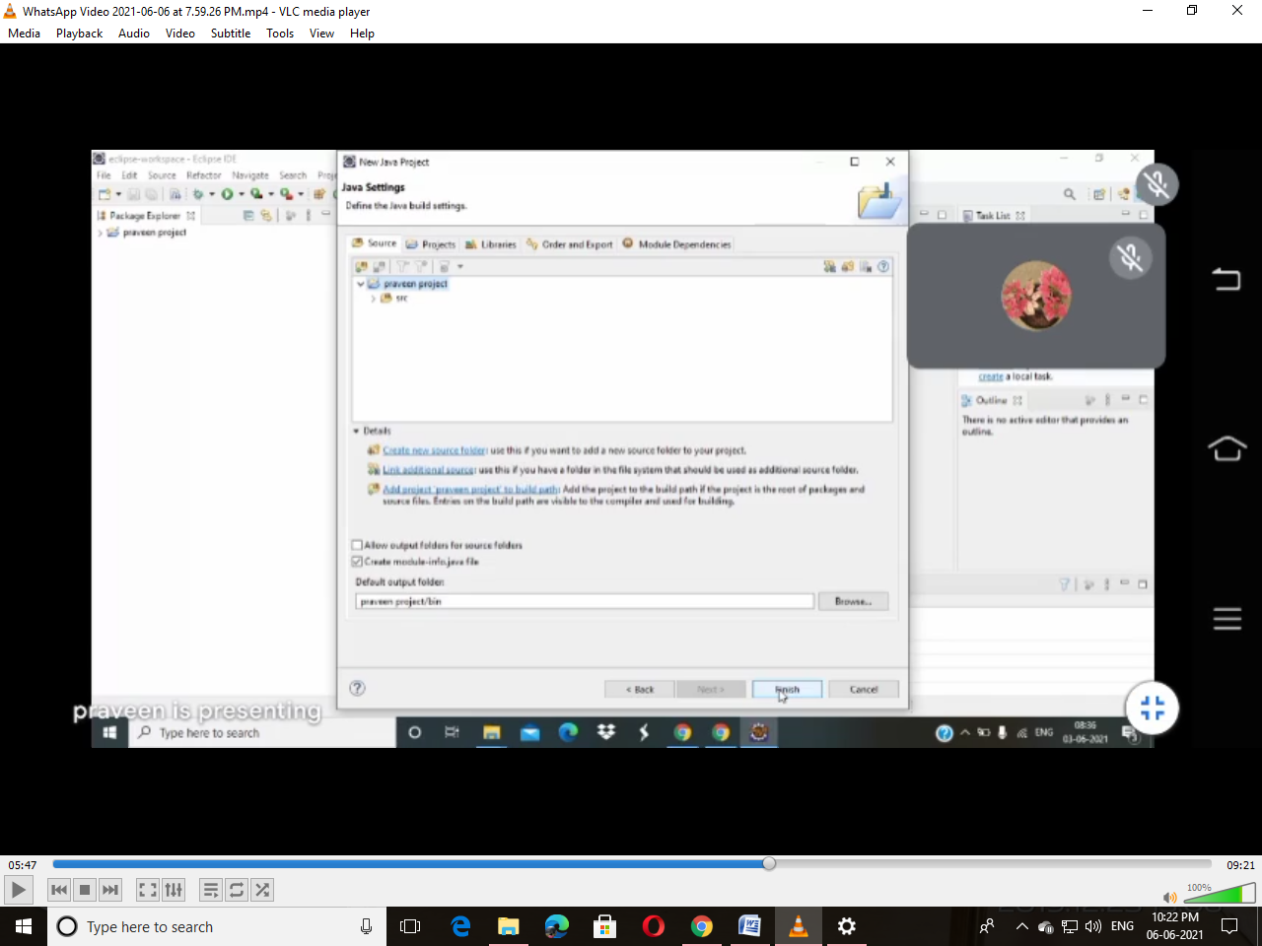

Step16:Select Don’t Create Button

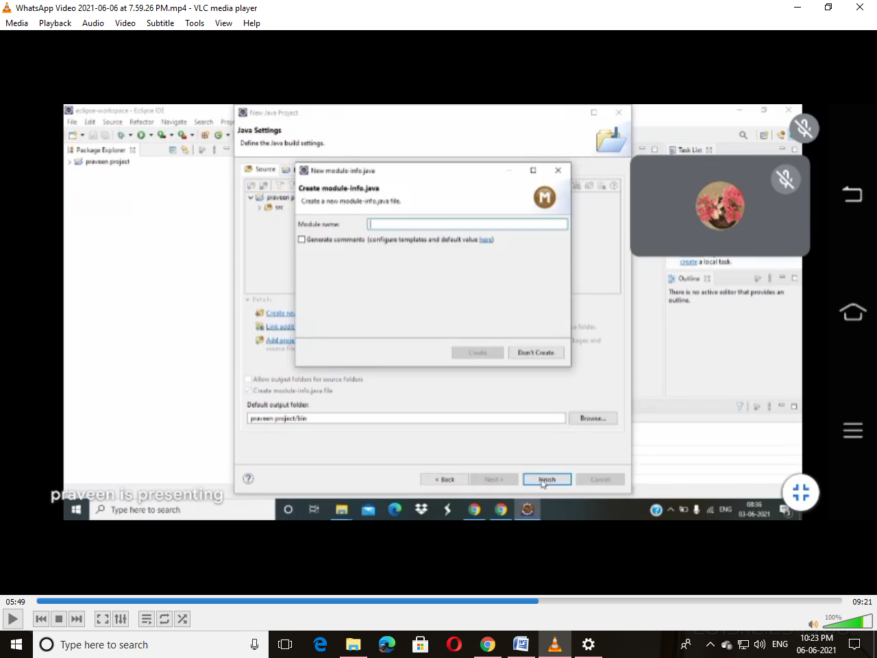

Step17:Close Task list and Outline Window

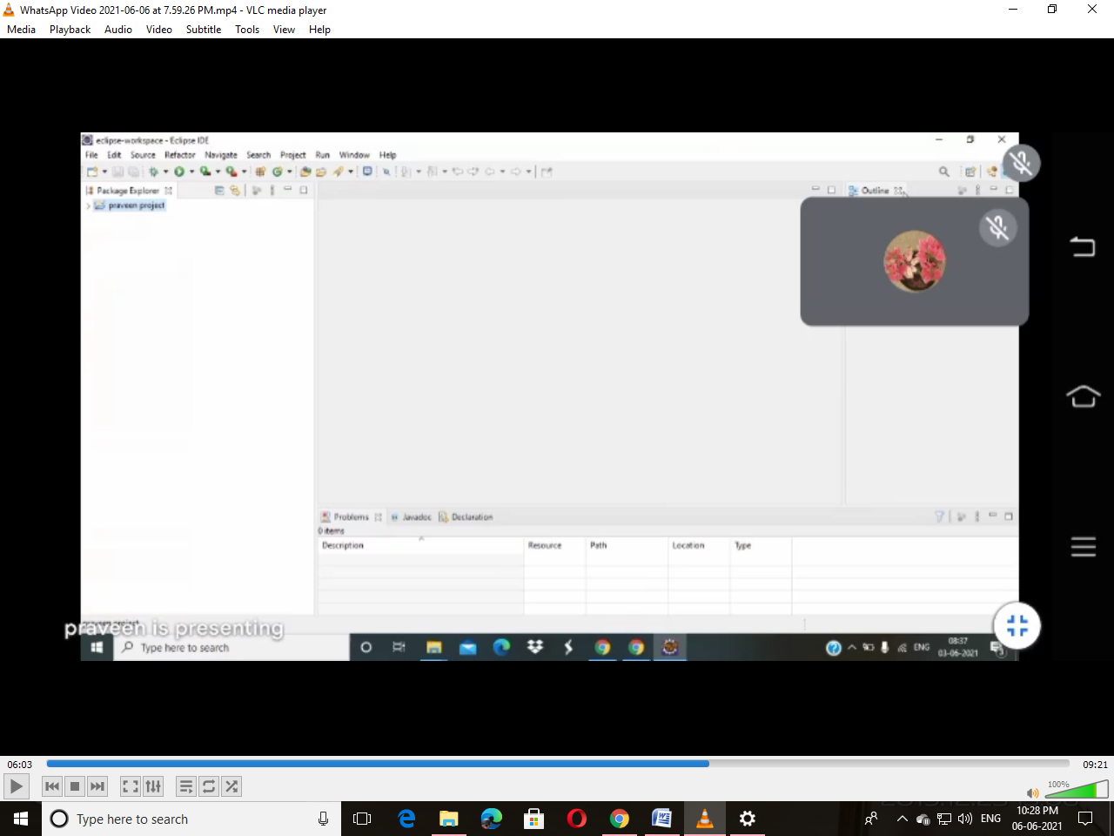

Step18: Click on Project Which is Created in your Name 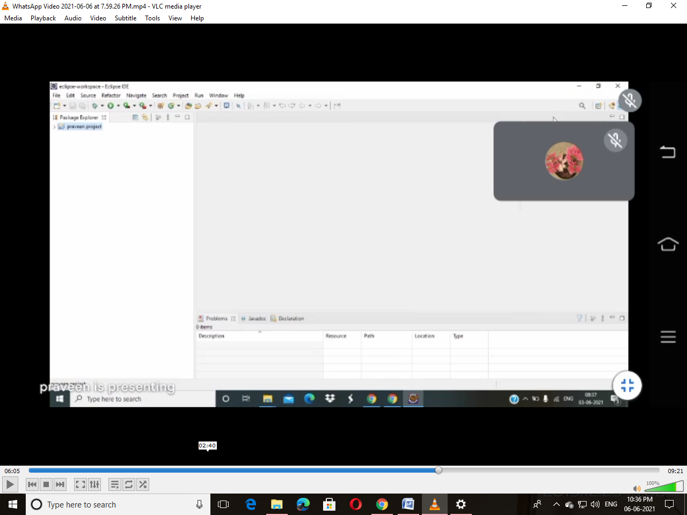

Step19:Right Click on Source (src)

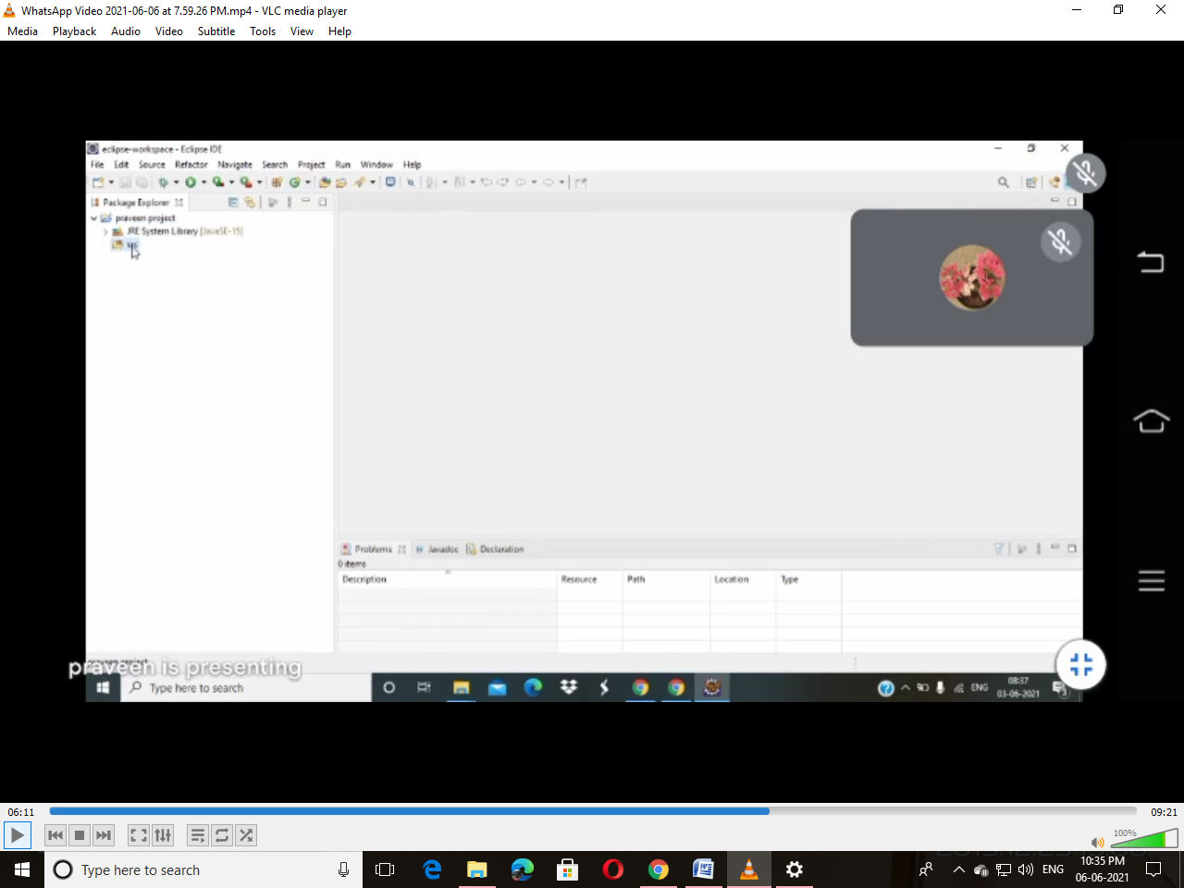

Step20:Select New in that Click on class

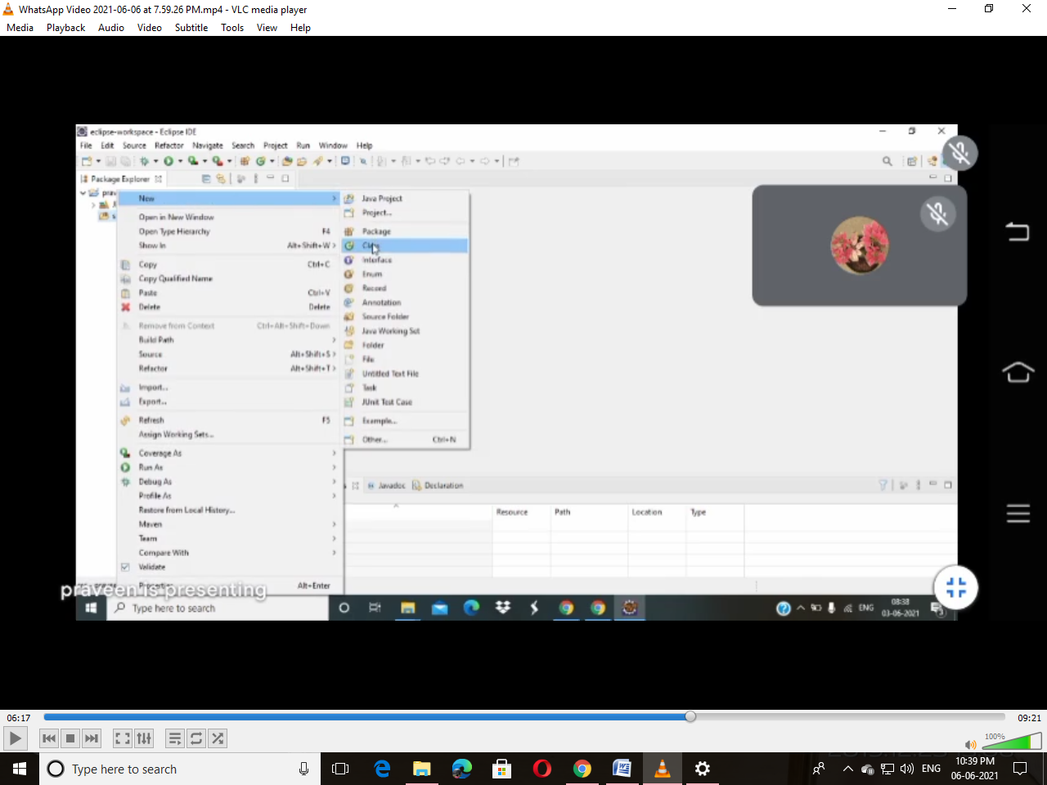

Step21:Give Name for Class and Click Finish Button

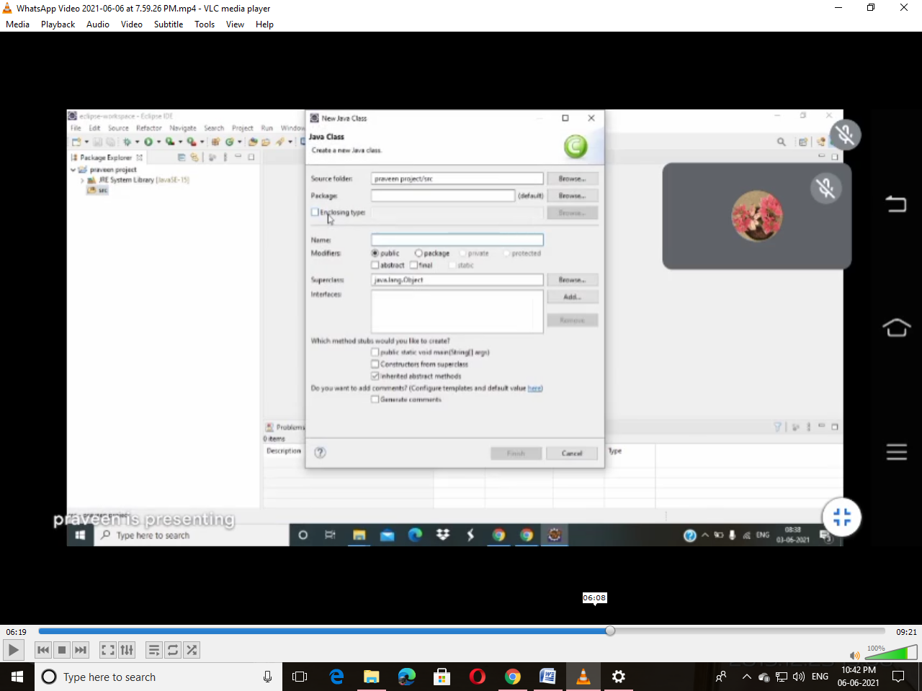

Step22:Write Some Sample Program

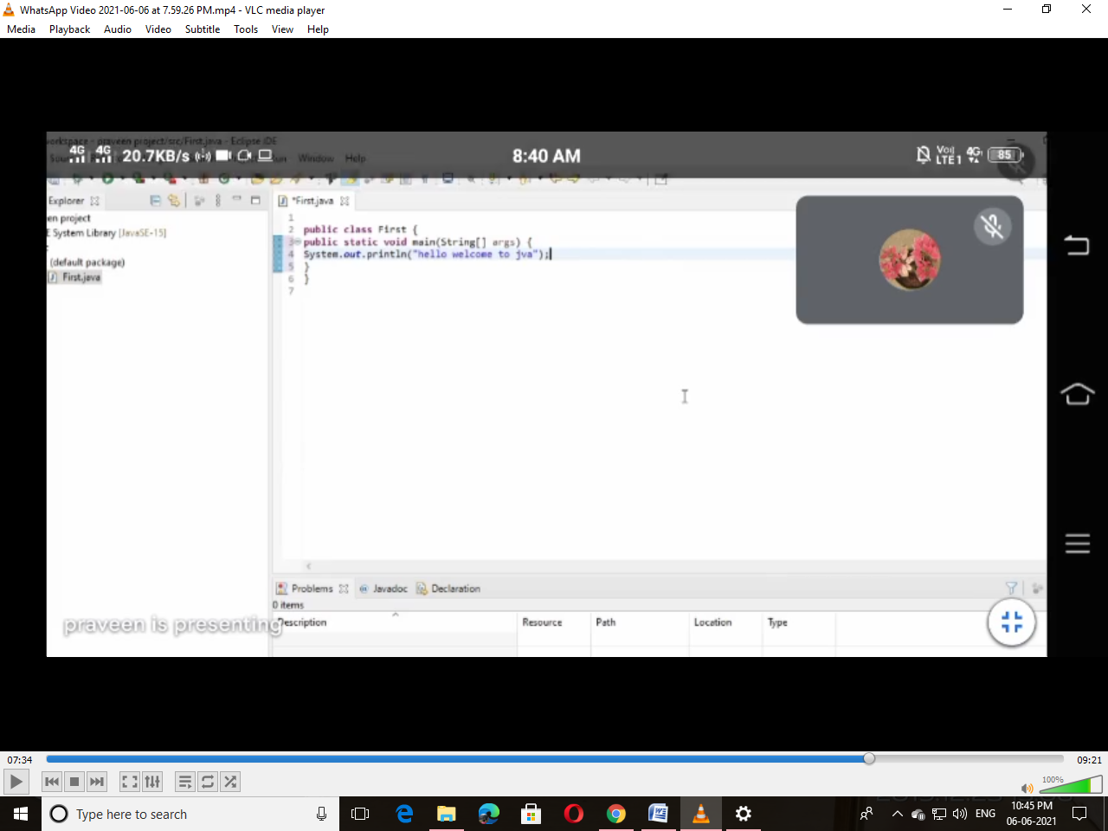

Step23:After Step22 Click Run Button(Left Side of the Window Green Colour Button)

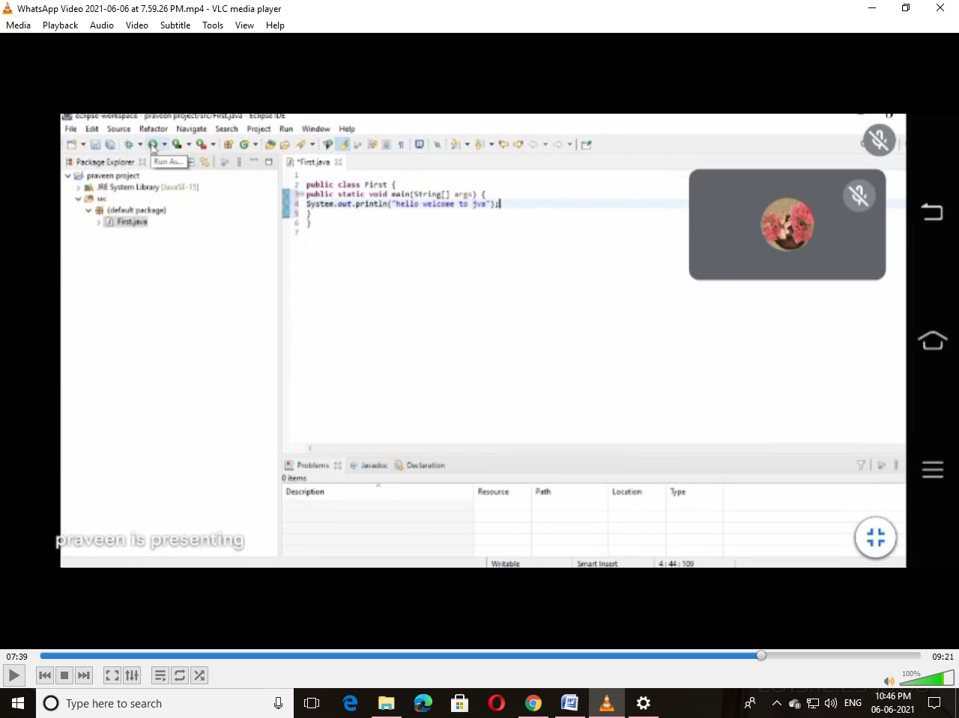

Step24:After Run the Program Click OK Button

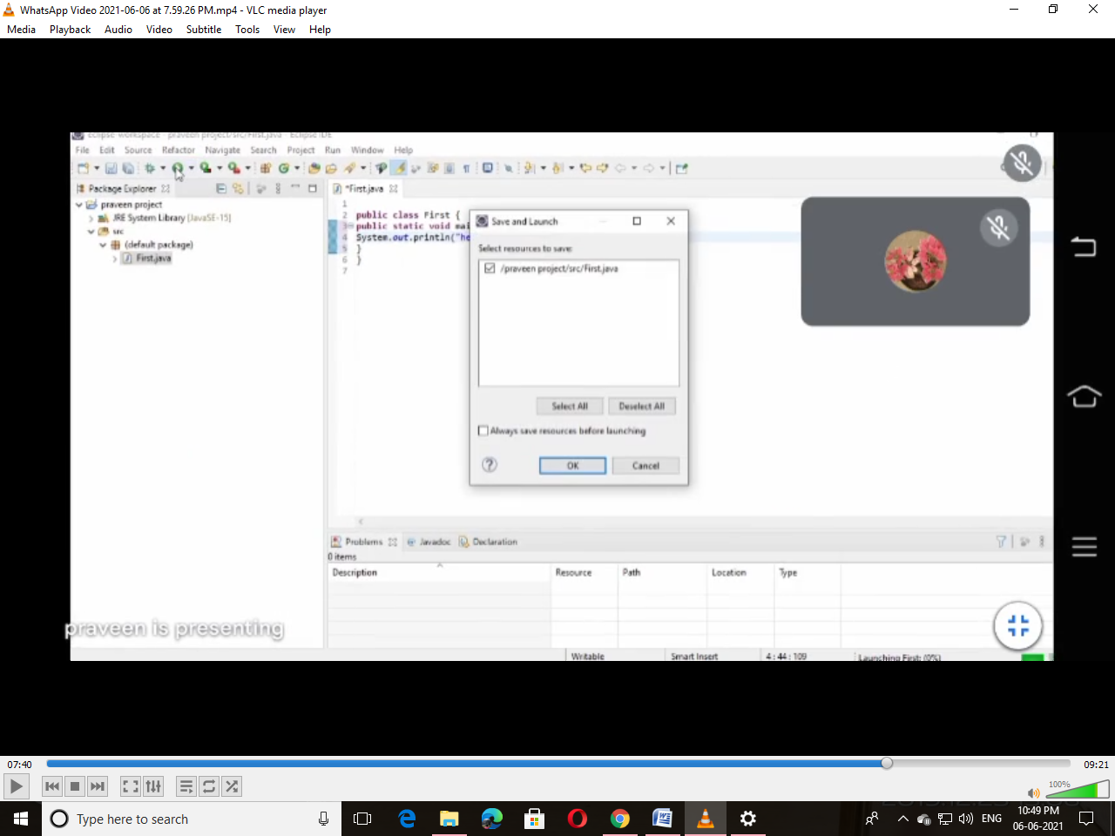

Step25:Result Will Be Displayed Below

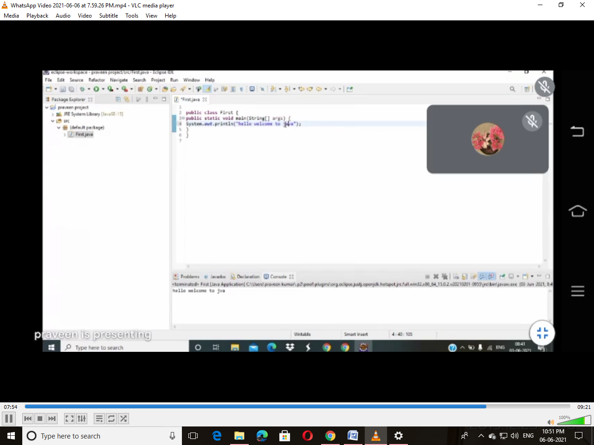

**SQl Commands**

**Create table Student(Rollno number,Name varchar2(20),Adress varchar2(2)**

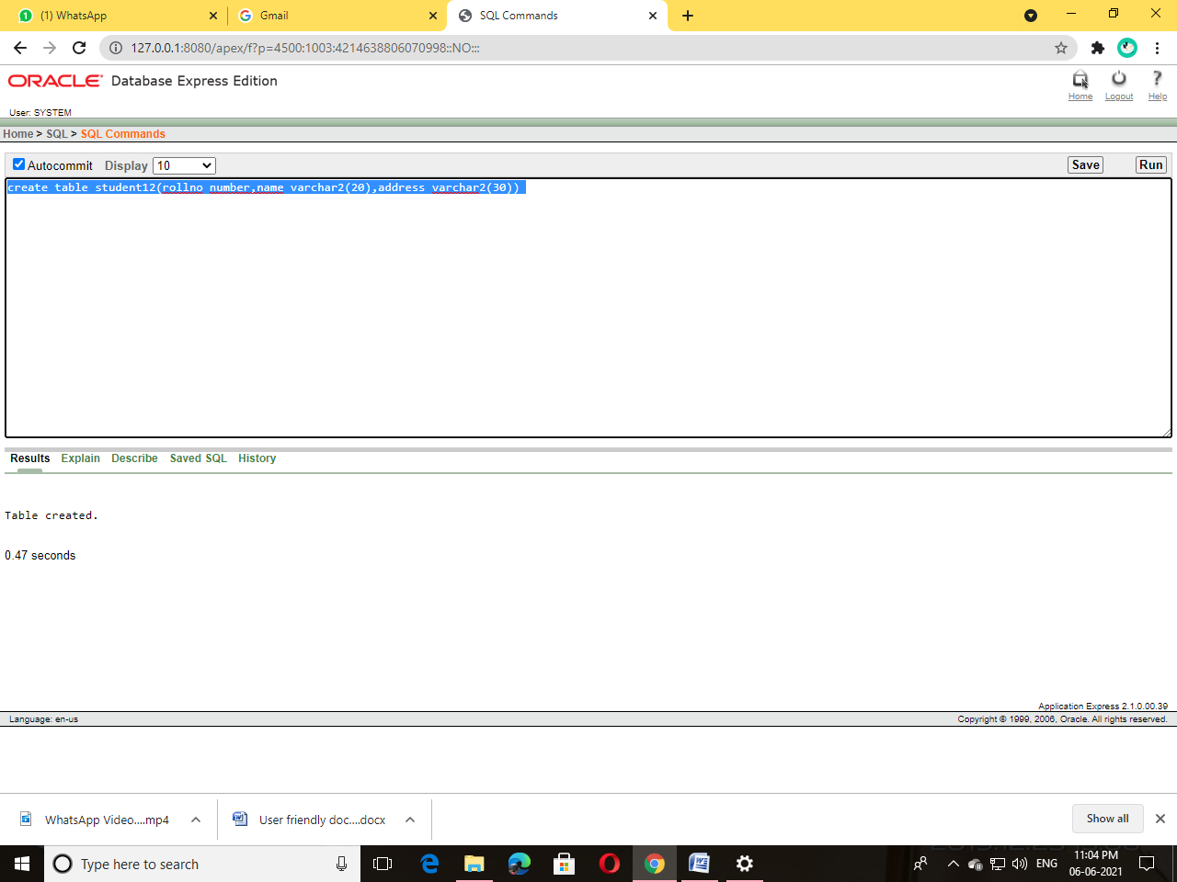

**Insert into Student values(101,’Tejas’,’R T Nagar’)**

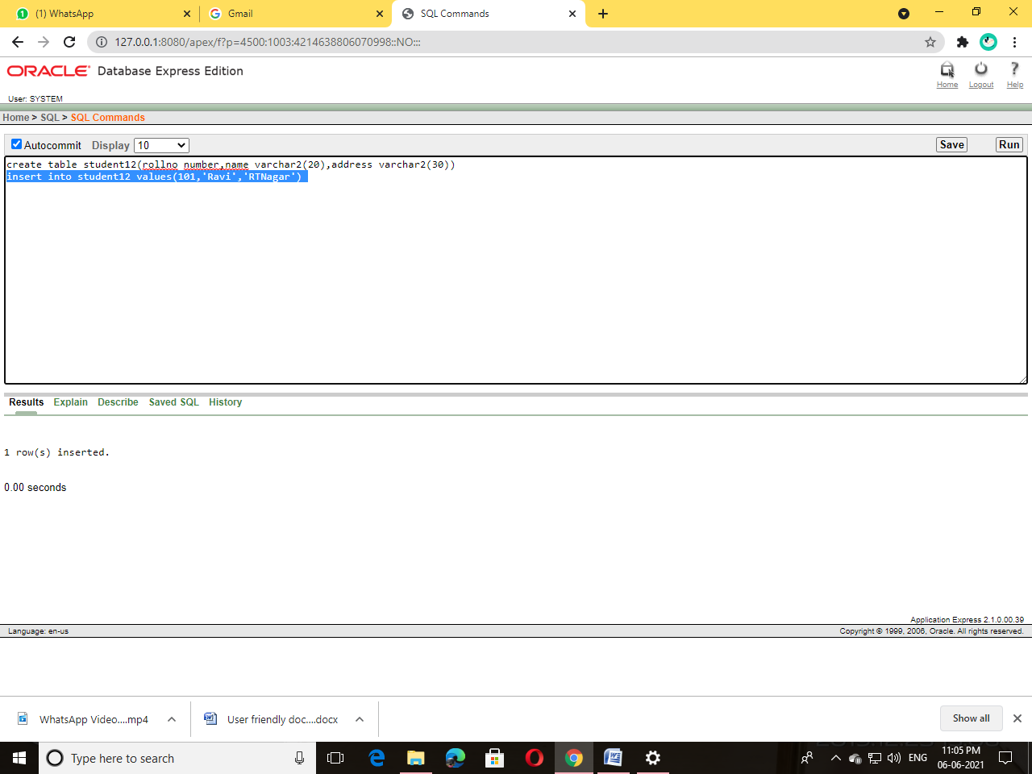

**Select * from Student**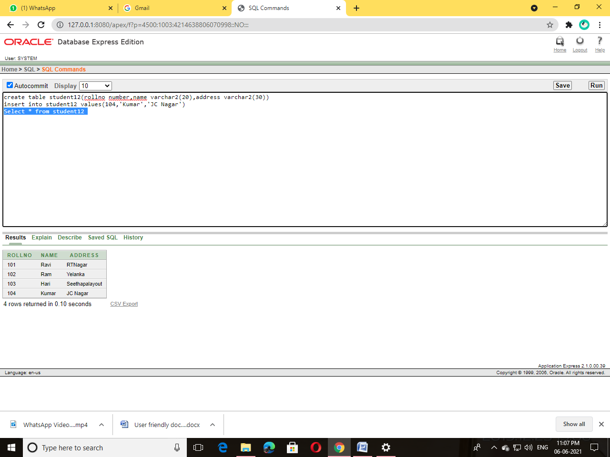

**Update Student set address=’chamundinagar’ where rollno=101**

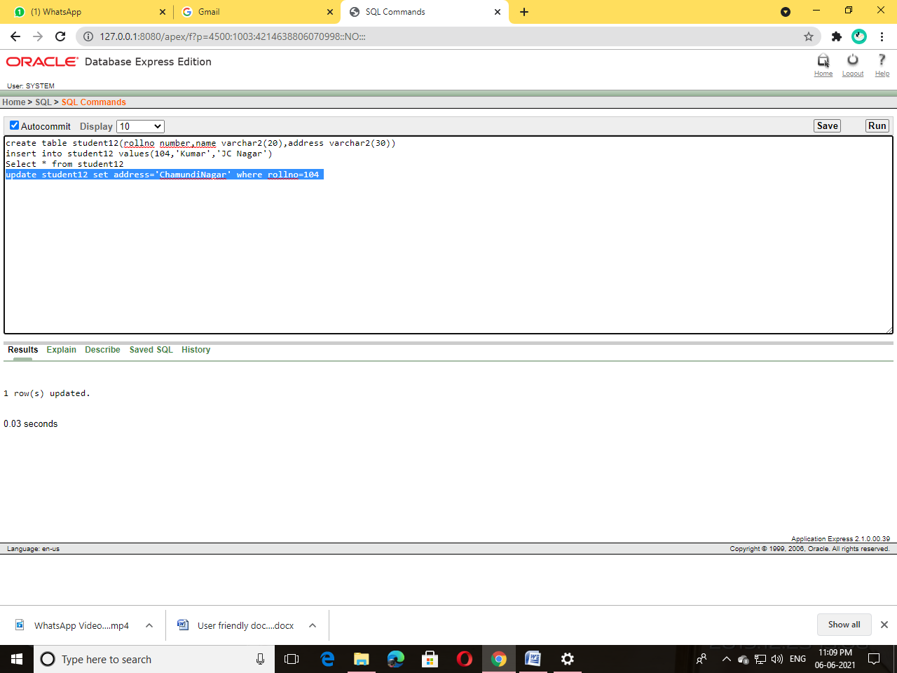

**Alter Command**

Alter table Student add UNIX number

Alter table Student add DBMS number

Alter table Student add VB number

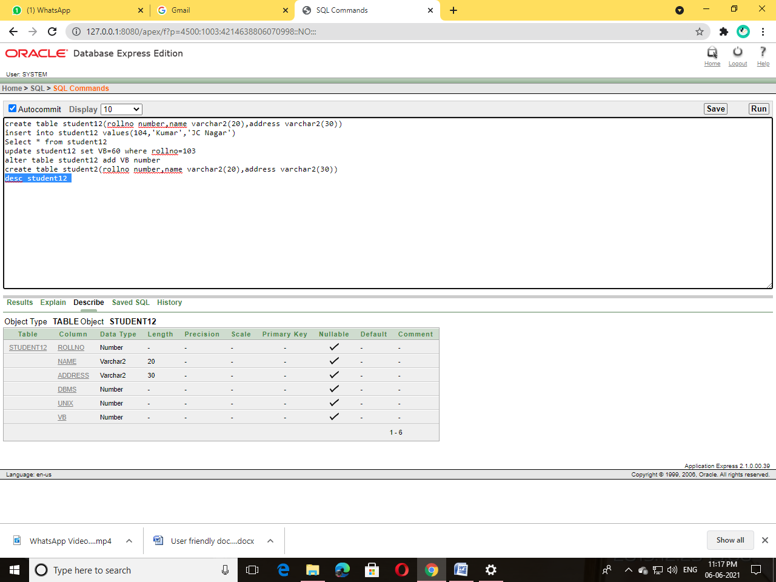

**Adding values to UNIX,DBMS and VB**

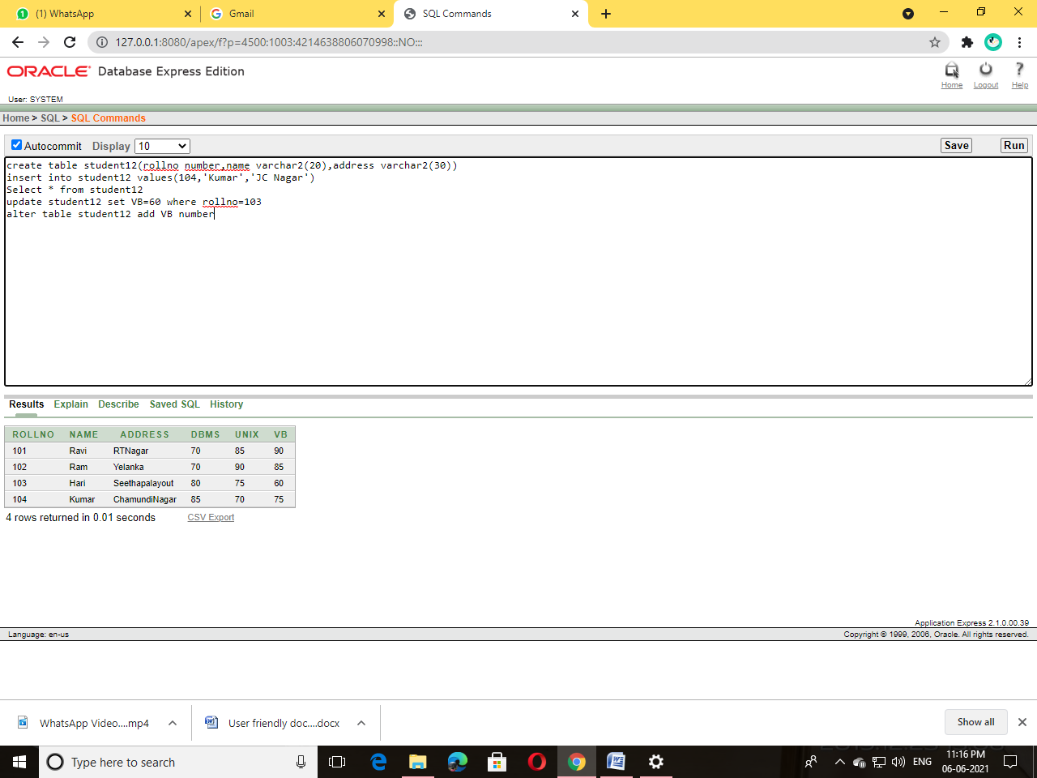

**Truncate Table Student**

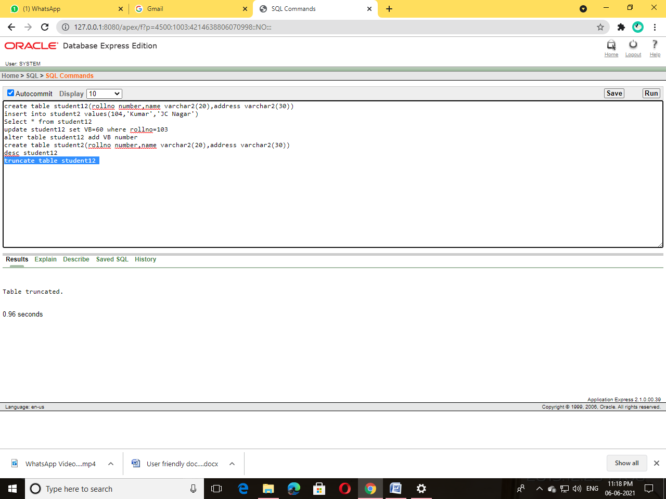

**Drop table Student**

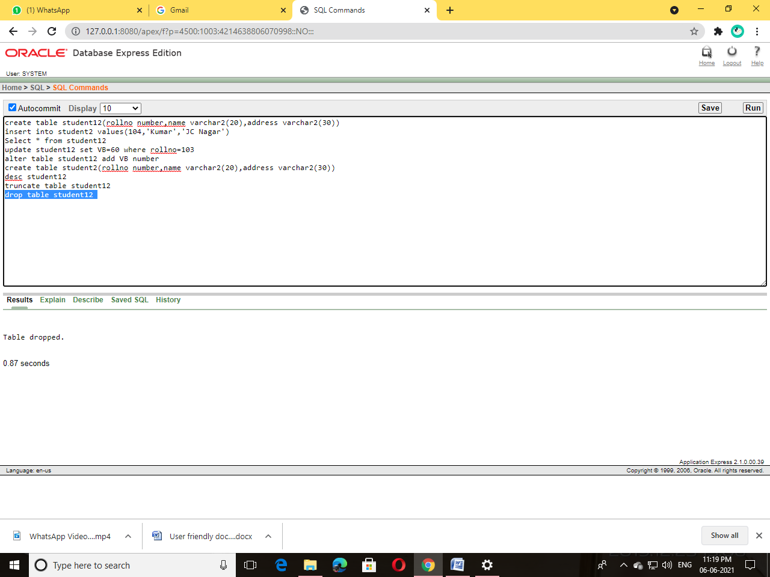

**Alter table Student add total number**

**Update Student set total=DBMS+VB+UNIX where rollno in(101,102,103,104)**

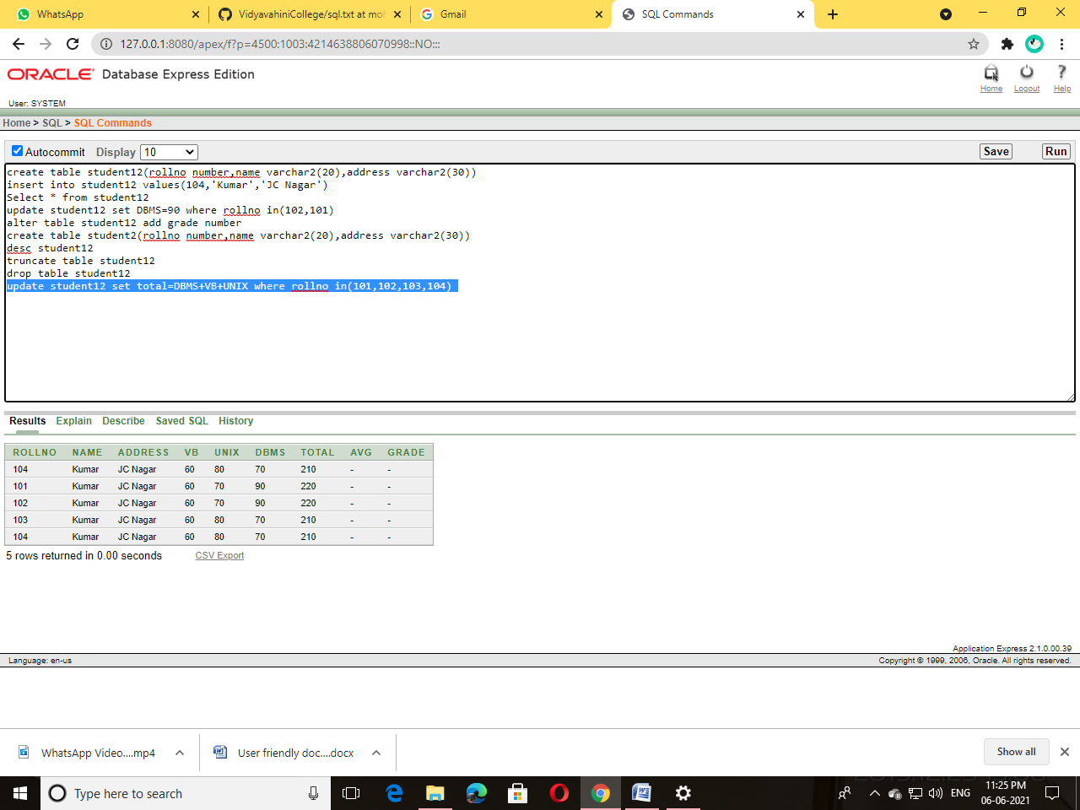

**Alter table Student add avg number**

**Update Student set avg=total/4**

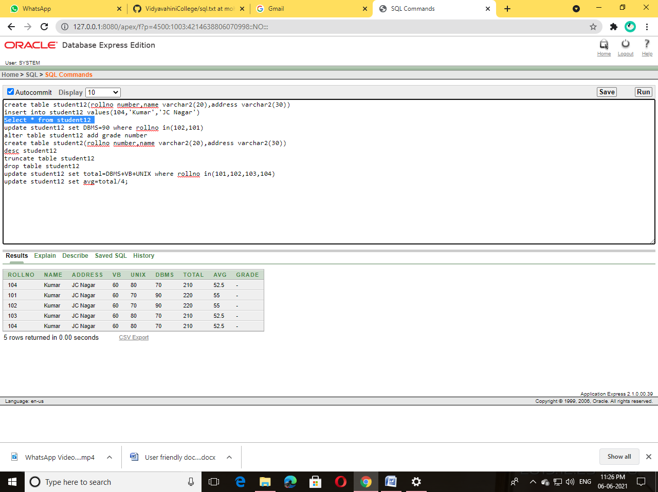

**Alter table Student add grade varchar2(20)**

Update Student set grade=’First Class’ where avg>60

Update Student set grade=’First Class’ where avg<60

